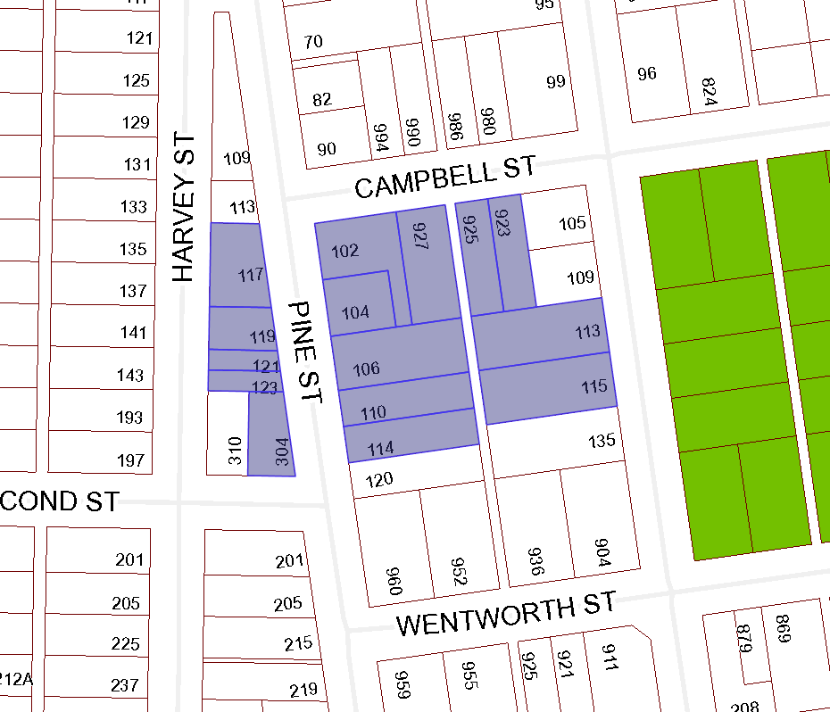

BOARD OF VARIANCE APPLICATION BOV00663

NOTIFICATION MAP

CIVIC: 106 Pine Street

LEGAL: SECTION A, OF LOT 2, BLOCK S, SECTION 1, NANAIMO DISTRICT, PLAN 584

